Assignment 3

Name(s): Vaibhav Raheja

NetID(s): vraheja3

## Part 1: Self-supervised Learning on CIFAR10

**1) Rotation training**  
During the rotation training phase, the model was trained for a total of 45 epochs, with a learning rate decay applied every 15 epochs. The initial learning rate was set at 0.01, eventually reducing to 0.001. This training strategy resulted in the model achieving an accuracy of 78.09% on a test dataset comprising 10,000 images, along with an average loss of 1.101. This phase served as an initial benchmark for evaluating the effectiveness of different training strategies on the model's performance.

**2) Fine-tuning late layers**

The experiment proceeded to investigate the impact of fine-tuning the late layers of the neural network. This phase was conducted using two different setups: a pre-trained model and a randomly initialized model, both subjected to 20 epochs of training with a learning rate decay after 10 epochs, starting from an initial rate of 0.01 down to 0.001.

* Pre-Trained Model: The fine-tuning of a pre-trained model led to an accuracy of 72.20% and an average loss of 1.642 on the test dataset.
* Randomly Initialized Model: In contrast, fine-tuning a randomly initialized model resulted in a significantly lower accuracy of 46.57% and a higher loss of 3.027.

This comparison highlights the benefits of utilizing pre-trained models as a foundation for fine-tuning, especially when focusing on adjusting the late layers of the model.

**3) Fully supervised learning**

In the final phase, the experiment explored fully supervised learning by fine-tuning the entire model, again comparing the performance of a pre-trained model against a randomly initialized one under identical training conditions.

* Pre-Trained Model: With full model fine-tuning, the pre-trained model reached an accuracy of 81.56% and an average loss of 1.080 on the test dataset.
* Randomly Initialized Model: Surprisingly, the randomly initialized model slightly outperformed the pre-trained model, achieving an accuracy of 82.36% with an average loss of 1.064.

This outcome suggests that with comprehensive training, even randomly initialized models can achieve comparable or superior performance to pre-trained models. It also illustrates the potential benefits of full model fine-tuning over merely adjusting the late layers, as it allows for a more thorough optimization of the model's parameters.

## Part-2: Object Detection by YOLO

1. My best mAP value on Kaggle:
   1. 0.49078
2. Did you upload final CSV file on Kaggle:
   1. Yes
3. My final loss value:
   1. 1.698
4. What did not work in my code(if anything): -
5. Sample Images from my detector from PASCAL VOC:
   1. 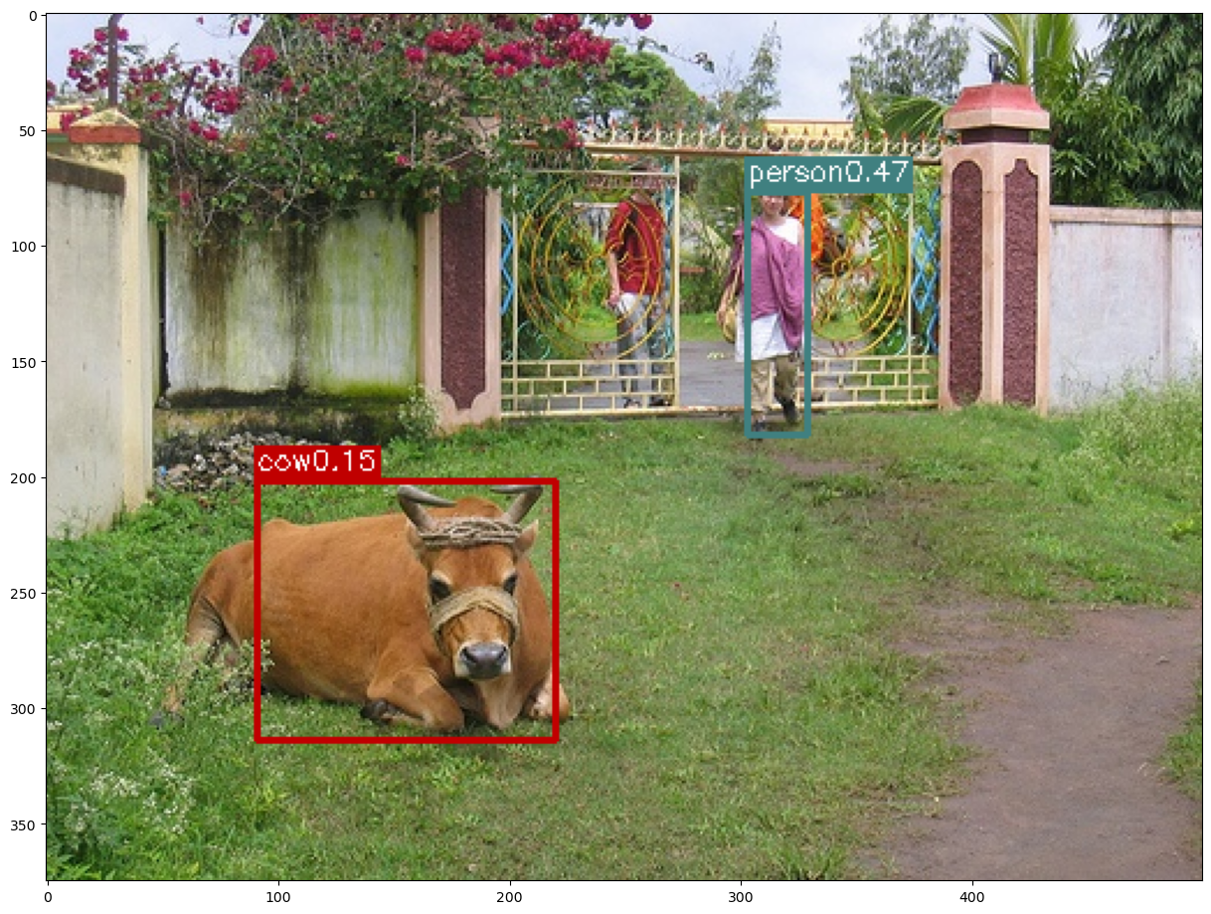
   2. 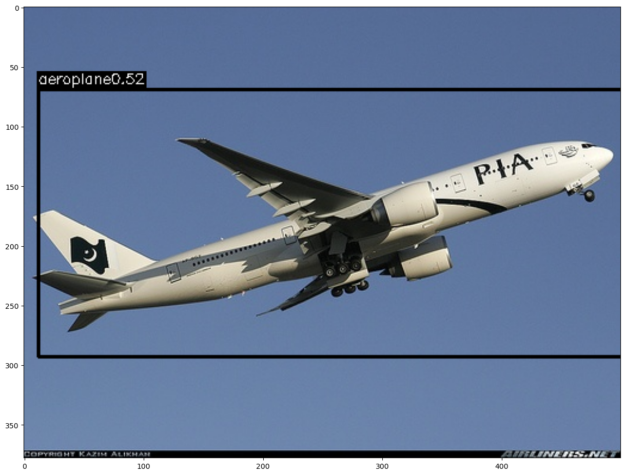
   3. 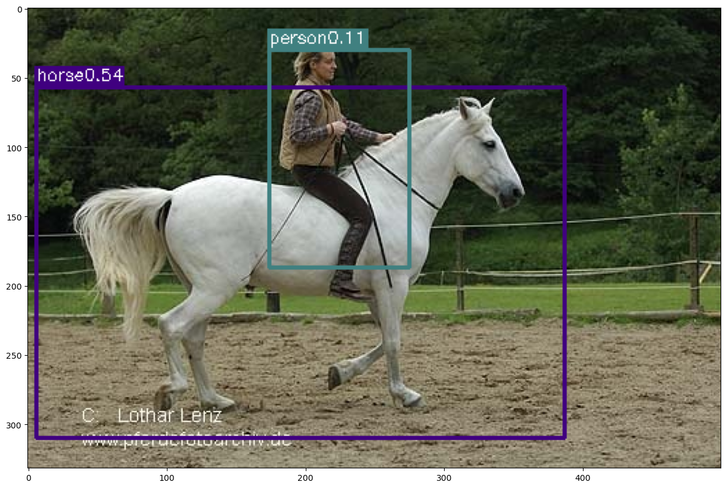
   4. 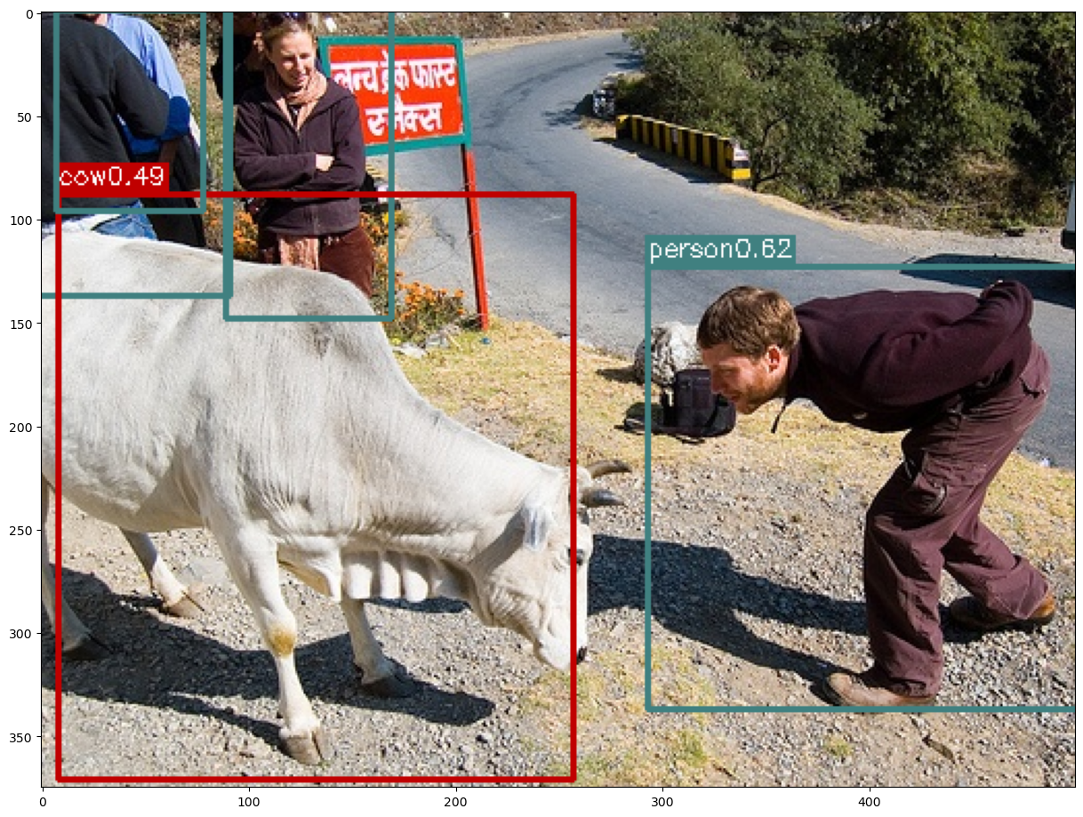

**Extra Credit** for YOLO:

[Output](https://drive.google.com/file/d/1i_tLdpKok2tw__GyDP8Uc8bX_9D9GoeA/view?usp=sharing)